Socio-economic devastation caused by the occupation of territory of Azerbaijan Republic by Republic of Armenia, 1991-1994.

As the result of aggression by the Republic of Armenia against the Republic of Azerbaijan, during the 1988-1994 period, serious material damage has been inflicted, currently estimated at $22 billion dollars.
Overall area of the occupied territories of the Republic of Azerbaijan includes:
- the territory of the Nagorno-Karabakh region (former Nagorno-Karabakh Autonomous Oblast (NKAO), abolished in 1991);
- the territories of 7 regions bordering with Nagorny Karabakh (Aghdam, Fizuli, Djabrail, Zangelan, Gubadly, Lachin and Kelbajar);
- the territories of 4 regions bordering with Armenia (Gazakh, Agstafa, Tovuz and Gedabey);
- the territories of 4 regions bordering with the Line of Contact (Ter-Ter, Goranboy, Agdjabedi and Beylagan);
- the territories of the administrative regions of the Nakhichevan Autonomous Republic (Azerbaijani exclave, separated from the rest of the republic in 1920),
Total: 17,000 sq.km. (10,563 sq. miles)
Occupied regions of Azerbaijan has been totally destroyed and robed. The great economic damage has been inflicted also to 4 regions of Azerbaijan bordering with Armenia, 4 regions bordering with the Line of Contact and the territories of the administrative regions of the Nakhchivan Autonomous Republic.
Detailed data on each of the seven occupied regions of Azerbaijan Republic – excluding Nagorno Karabakh (former NKAO) and regions bordering Armenia or Line of Contact, suffering from minor occupation or continued hostilities – are provided below:

LACHIN DISTRICT  15 - 18 May 1992  - territory – 1,835 sq.km  - number of families - 14095  - number of population - 61763 persons  - female - 31278 persons  - children - 24705 persons  - number of murders - 324 persons  - number of handicaps - 1125 persons  - number of orphans - 1200 persons  DESTRUCTION AND LOSSES:  - villages and settlements - 120  - dwelling houses - 8949  - industrial and construction establishments - 7  - service establishments - 471  - schools - 154  - health care centers - 30  - cultural establishments - 360  - farms - 40 | 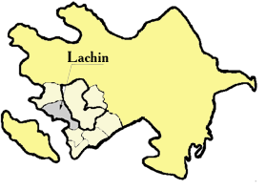

KELBAJAR DISTRICT  31 March - 2 April 1993  - territory – 3,054 sq.km  - number of families - 14780  - number of population - 60698 persons  - female - 31363 persons  - children - 24279 persons  - number of murders - 458 persons  - number of handicaps - 510 persons  - number of orphans - 734 persons  DESTRUCTION AND LOSSES:  - villages and settlements - 150  - dwelling houses - 11130  - industrial and construction establishments - 8  - service establishments - 383  - schools - 97  - health care centers - 120  - cultural establishments - 318  - farms - 54  - museum - 1  - sanatorium -1 | 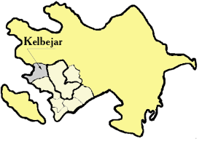

JABRAIL DISTRICT  23 August 1993  - territory – 1,050 sq.km  - number of families - 14112  - number of population - 57125 persons  - female - 30277 persons  - children - 22850 persons  - number of murders - 353 persons  - number of handicaps - 368 persons  - number of orphans - 218 persons  DESTRUCTION AND LOSSES:  - villages and settlements - 96  - dwelling houses - 9242  - industrial and construction establishments - 17  - service establishments - 383  - schools - 114  - health care centers - 17  - cultural establishments - 138  - farms - 44 | 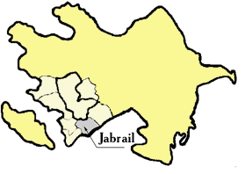

AGDAM DISTRICT  23 August 1993  (partially occupied)  - territory - 1154 sq.km  - number of families - 36054  - number of population - 158000 persons  - female - 82160 persons  - children - 63200 persons  - number of murders - 538 persons  - number of handicaps - 587 persons  - number of orphans - 987 persons  DESTRUCTION AND LOSSES:  - villages and settlements - 122  - dwelling houses - 24446  - industrial and construction establishments - 48  - service establishments - 1317  - schools - 160  - health care centers - 65  - cultural establishments - 373  - theatre - 1  - museums - 2  - mosques - 3 | 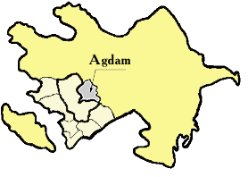

GUBADLI DISTRICT  30 August 1993  - territory - 802 sq.km  - number of families - 8331  - number of population - 30678 persons  - female - 16260 persons  - children - 12080 persons  - number of murders - 80 persons  - number of handicaps - 722 persons  - number of orphans - 435 persons  DESTRUCTION AND LOSSES:  - villages and settlements - 95  - dwelling houses - 6999  - industrial and construction establishments - 15  - service establishments - 291  - schools - 78  - health care centers - 13  - cultural establishments - 285 | 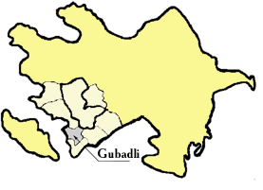

ZANGELAN DISTRICT  20-23 October 1993  - territory - 707 sq.km  - number of families - 8640  - number of population - 34924 persons  - female - 17950 persons  - children - 12800 persons  - number of murders - 490 persons  - number of handicaps - 345 persons  - number of orphans - 395 persons  DESTRUCTION AND LOSSES:  - villages and settlements - 93  - dwelling houses - 5779  - industrial and construction establishments - 15  - schools - 86  - health care centers - 15  - cultural establishments - 279  - farms - 29 | 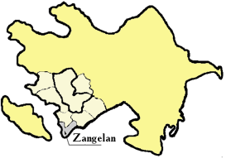

FIZULI DISTRICT  August 1993  (partially occupied)  - territory – 1,386 sq.km  - number of families - 22110  - number of population - 98958 persons  - female - 52561 persons  - children - 36321 persons  - number of murders - 669 persons  - number of handicaps - 1450 persons  - number of orphans - 155 persons  DESTRUCTION AND LOSSES:  - villages and settlements - 77  - dwelling houses - 15213  - industrial and construction establishments - 33  - service establishments - 786  - schools - 117  - health care centers - 43  - cultural establishments - 166  - farms - 50 | 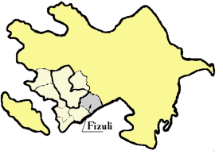

To find out more about Armenian aggression and occupation of Azerbaijani territories, as well as all ASA activities and how to help, visit official website of ASA: http://www.azerbaijan-america.org. Researchers can also visit Karabagh.com, Karabakh.org and Khojaly.net websites for more information.

